Page 173 Start ---
complete, process flow continues on to the end of the process at which point the process instance is considered complete.
完成，实例流程继续运行直至流程的结束，此时这个流程被认为是完整的.

Now let us introduce an additional modeling construct. Visually, it looks as follows:
现在我们使用一个额外的构造建模，表面上它看起来如下:

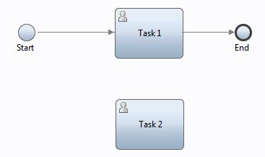
What is different in this diagram is the addition of a second User Activity called "Task 2".
这个图中不同的活动是新添加的第二个用户活动’Task 2’。

However, this activity is considered to be "unwired".
然而，这个活动被认为是不活跃的。

What we mean by that is that there is no path leading into the activity and hence it would appear to be non executable.
我们的意思也就是说它没有被一个主要路径去引导执行它，因此它将是一个不可执行的活动。

New in 8.5.5, these unwired activities have new semantics.
在最新的版本8.5.5中，这些不活跃的活动有了新的语义。

The semantics will be described momentarily but first, let us look at the details of the new Process Designer implementation tab which
is where we will configure the operational attributes:
我们将首先讲述这语义，让我们看看在新的流程设计实现中选项卡的详细信息中进行配置:

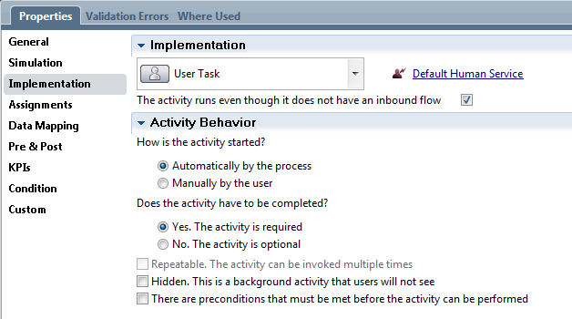
Within the implementation section, there is a new grouping of configuration properties under the
banner of "Activity Behavior".
在这实现部分有一个新的配置属性分组’Activity Behavior’。

It is here we will concentrate most of our discussion.
我们将集中大部分的讨论在这里。

However, before we do that, there is a simple piece of housekeeping we need to get out of the way.
然而，在这之间有一个简单的家务我们需要绕开。

Prior to version 8.5.5 activities placed in a BPD but with no input links to them were simply Ignored.
在先前的8.5.5版本中的把一个活动安排放到一个BPD里但是忘记给它输入链接。

This meant that activities could be left within a BPD during testing with no side effects (other than potential clutter) to the operation of the BPD.
这意味着那个活动在BPD的测试期间不会被开启(不同于潜在的混乱)同时也不会影响BPD的运行。

A developer might leave these unwired artifacts in place for future regression testing or for other purposes.
开发人员可能在某些时候可能遗忘这些不活跃的组件比如未来的回归测试或其他时候.

With 8.5.5, unwired artifacts now have new meaning but this could result in BPDs brought in through migration from earlier
releases no longer working as expected and that could be disastrous.
现在8.5.5中的不活跃的组件有了一个新的含义，但是在早先的版本在进行迁移BPD的时候可能导致其不按预期工作，其结果可能是灾难性的。

Fortunately, IBM has provided a solution. Immediately above the Activity Behavior header is a check box labeled "The activity runs even though it does not have an inbound flow".
幸运的是IBM提供了一个解决方案.马上为以上活动行为勾选一个复选框‘The activity runs even though it does not have an inbound flow’。

If this box is checked (which is the default) then the new 8.5.5 processing will happen for unwired activities.
如果这个复选框被勾选（默认被勾选）那么在最新的8.5.5版的过程中将标记为不活跃的活动。

If the box is not checked, then the activity will be ignored and operation of the process as a whole
will behave as though the activity were not present.
如果这个复选框没有被勾选那么这个活动将被忽略并且过程的操作将认为这个活动不存在。

Page 173 End ---

Page 174 Start ---

Migrated BPDs prior to 8.5.5 will have the option unchecked while new BPDs will have the default of checked.
在8.5.5的迁移BPDs中将可以选择不检查，因为BPD默认值是检查的。

Naturally, a person designing a process can manually change the setting as needed.
理所当然，个人设计过程中可以根据需要而手动设置。

Ok, with that out of the way, we can now start to discuss what it "means" to have an unwired activity in the process diagram.
Ok，先把这个话题放到一边去，我们现在开始讨论的是在这个流程图中有一个未连接的活动。

In simple terms, it means that the activity will "run" when the process is started and it will run in parallel to the primary entry flow of the process.
简单来说，他意味着这个活动在流程启动的时候将与流程的主要入口流一样跑起来。

Naturally, there is more to say about it than this, but one piece at a time. First, let us discuss the notion of an activity "running".
理所当然，还有更多比这更糟糕的话题要说，但是放到一个时间一起说。首先我们来讨论一个运行中的活动的概念。

When we start a BPD process we consider the flow as following the linkage from one activity to another.
在我们启动BPD流程的时候我们得考虑到一个活动到另外一个之间的链接流程如下。

An activity is said to be running (or executing) if the control flow of the process is currently at that activity.
一个活动如上述所述运行（或执行）如果在那个活动是目前流程的控制流。

Activities performed previously are considered finished and activities that may be performed later are simply not spoken about.
活动执行之前被认为已经完成那个活动可能在执行之后没有谈到。

If we consider that there are loosely two types of activity … those that are User Activities and everything else …
如果我们考虑到哪个活动有宽松的两个类型...那些无法控制的用户活动和其他的一切。

then a User Activity is said to be running if a user can see it in the task list and work upon it.
那么对一个用户活动被认为正在运行中如果一个用户能在任务列表中看到他并且能正常工作。

A system activity that is running is one which is actively performing computations or integration logic.
一个系统活动也就是说一个正在运行中的活跃的计算执行或集成逻辑。

We have just said that unwired activities will run when the process instance starts however, a new state is now available for unwired activities.
我们只需要认为这个不活跃的活动将在流程实例启动的时候运行，然而一个新的状态会出现在这个不活跃的活动上。

That state is called "ready". An activity that is ready logically exists but it is not able to run.
这个状态叫做‘ready’。那时一个准备好逻辑并且存在的活动但是它不会运行。

In order for it to run, it must be explicitly "started".
为了让它有秩序的运行，他必须明确“started”。

Once it has been started, it may then run when it is able.
一旦它已经启动，那么它就能够运行。

So … thats a lot of words … lets see if we can't make some of it concrete.
所以...这是很多的话语...让我想想如果我们不能做一些具体的事。

Within the Activity Behavior section there is a radio button option which says that an unwired activity may be either started automatically or manually.
在这个活动部分行为有一个单选框选项来表示一个不活跃的活动可以被启动的方式自动或手动。

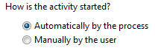

Automatically simply means that the activity will immediately enter its runnable state.
自动的话简单来说那个活动将立即进行可运行状态。

For a User Activity, this means that it will be a task in the user's task list able to be worked upon.
对于一个用户活动，这意味着它将是一个任务并且存在于用户任务列表里并能够进行工作。

For example,if we run this process and Task 2 is flagged as automatically started, in the task list we will see:
举个例子，如果我们运行流程和任务 2并且已经标记为自动，在任务列表里我们可以看到下面：

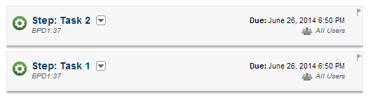

And that makes sense. Both Task 1 and Task 2 are running and hence can be worked upon.
这是情理之中的，任务1和任务2正在运行中并且他们可以进行工作。

If the unwired activity is a different type of activity than a User Activity, it will simply do what it does.
如果不活跃的活动是一个不同活动类型而不是一个用户活动，它将会简单做它该做的事。

But what if we flag an unwired activity start type as manual?
但是如果我们标记不活跃的活动的启动类型为手动呢?

What this means is the activity will not show up in the user's task list.
这意味着这个活动将不会出现在用户任务列表里面。

It is n't runnable. If we flag the activity as being manually started by the user, it is given a new icon decoration:
它是不运行的。如果我们标记这个活动是由用户手动开启，它有了一个新的图标进行标识看下面:

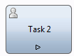

The small triangle is used to indicate that it is manually started. This now begs the question … how
then does one start such an activity?
这个小三角表示是一个手动启动的活动。这引出了一个问题...我们该如何启动这样的一个活动?

The answer to this is through the Processes tab within Process Portal
答案是这个可以通过Portal里的Processes选项卡去启动。

Page 174 End -
Page 175 start -
If we drill down to the process instance which contains our tasks, we see the following:
如果我们去深入探讨包含我们任务的流程实例，我们可以看到下列事物:

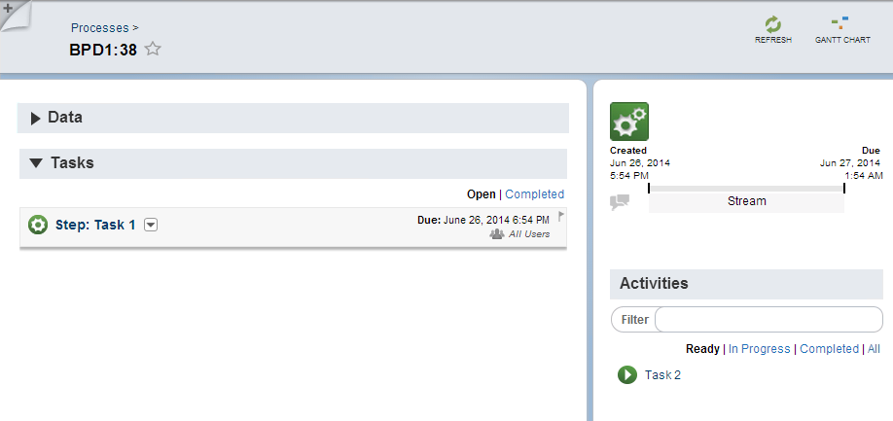

We see that Task 1 is indeed a running task for this process. No surprise there … however we
have a new section in the bottom right called "Activities". In there we see an icon for Task 2.
我们看到那个Task1对于这个流程来说是真正的运行中的一个task。
不要惊讶...然而我们有一个新的部分在这个按钮右边名为"Activities"。在这里我们可以看到Task2的图标。

The way we should interpret this is that there is a task called "Task 2" that is ready to be started.
从样子来看我们应该解释为这是一个名为”Task2”的任务它已经准备好启动。

If we were to start it, it would become runnable and hence appear as a new task for the process as a
Whole.
如果我们要启动它，它将变成可运行的并且因此出现一个新的任务在这个过程里以一个整体的身份出现。

If we click on Task 2, a menu of options is shown to us:
如果我们点击Task 2，一个可选的菜单的选项出现在我们眼前:

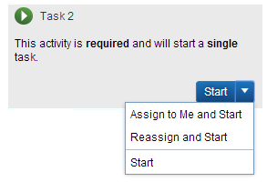
From here we can assign it to ourselves, assign it to ourselves and start it, we can assign it to a
named user and start it or simply start it as yet unassigned to anyone. Once it is started, the new
display looks as follows:
在这里我们可以将它分配给自己，将它分配给自己并且启动它，我们可以分配他给指定的用户
并且启动它或者仅仅是启动它但是不分配给任何用户，一旦它已经启动完成，新的显示就会出现，如下:

Page 175 End -

Page 176 Start -
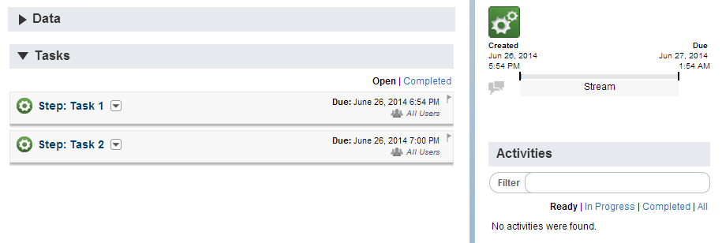

If we contemplate this, we should now start to see that we have control over when the new task is
made available to a user to work upon.
如果我们考虑这个问题，在新的任务可以被用户使用的时候我们现在应该开始看到我们可以控制它。

Hopefully you are still with me on this story. As mentioned, it is quite subtle and there is yet more
to discuss.
我希望你仍然还在和我探讨这个故事，关于以上提到的，它是很微妙的并且还有更多的讨论。

What if we complete Task 1 without starting Task 2. Does that mean that process is completed?
假设我们完成这个Task 1 之后没有开启task2。那么这个流程到底完成了么？

Well … that depends on another setting. An unwired activity can be tagged as either
optional or required (the default). A required activity must be completed before the
process as a whole is considered completed.
很好...这要取决于另外一个设置了。一个不活跃的活动可以被标记为可选或者必需(默认是必需)。
作为一个整体一个必需的活动必须被完成之后这个流程才被认为是完成的。

This is irrespective of whether or not the unwired activity is started manually or automatically.
这与是否选择手动或自动启动是无关系的。
If the unwired activity if flagged as manual and has not been started but yet the rest of the process completes,
the process will not be considered complete until the unwired activity is subsequently started and completed.
如果这个不活跃的活动标记为手动并且还么有开始但是其余的过程完成之后，这流程将不认为已经完成，
直到这个不活跃的活动启动并且完成之后这个流程才算完成.

Another way to say this is that if an unwired activity is flagged as required then at some time
before the process completes, that activity must be run. It may mean that the activity has to be first
started but either way, it must be run.在流程完成之间的某个时候，这个活动必须运行，它可能
还有另一种说法，如果这个不活跃的活动呗标记成必需的那么意味着这个活动必须开始不管如何他必须运行。

Having just looked at an activity flagged required, now let us look at what the alternative which is
optional means. Firstly, a task flagged as optional has a dotted appearance on its border:
刚刚看到一个活动呗标记为必需的，现在让我们来看看这个活动长什么样什么。首先
这个被标记为可选的活动的边框线是虚线:

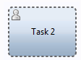
This gives us a visual indication as to whether it is required (solid border) or optional (dotted
border).
这给了我们一个直观的样式，是必需的（实现边框）或者可选的（虚线边框）。

If the unwired and optional activity is flagged as automatically started and the rest of the process
ends, the task must still be completed before the process as a whole is considered complete.
如果这是不活跃的活动并且是可选的活动被标记为自动启动并且剩余的流程结束，那么作为一个整体
这个任务必需在这之前完成，这个流程才能为认为是完成的。

If the unwired and optional activity is flagged as manually started something new happens. The
process portal looks as follows:
如果这是不活跃的活动并且是可以选的活动被标记为手动启动新发生的事物。在这个这个流程的portal里面的情况如下:

Page 176 End -
Page 177 Start-
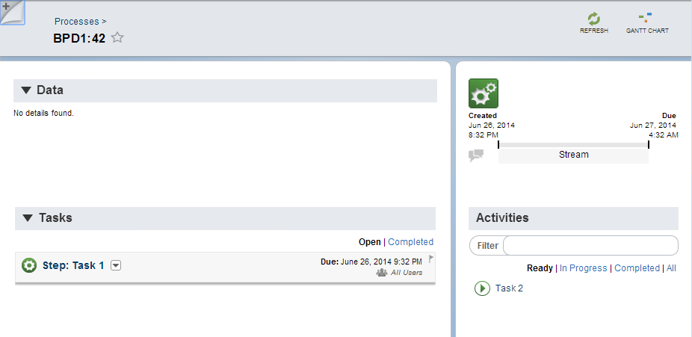
As expected, we see Task 1 running but notice the icon for Task 2. Instead of a green filled icon, it is a white filled icon.
正如所料，我么看到一个Task1正在运行中但是请注意Task2的图标。它不是一个绿色的图标，而是一个白色的图标。

This is the visual that it is optional.
这只是外观它是可选的。

If Task 1 is completed (and hence the rest of the process), the process as a while does come to an end.
如果这个Task1完成了（并且只剩下其他的流程），这个流程也就等同于走到了尽头。

Stating it another way, if an unwired and optional activity has not been started then if the process ends there is no need to start
(and hence run) that unwired activity.
这说明了另一种方式，如果它是不活跃的并且是可选的活动还没有开始，那么如果流程结束，那么就不需要启动（和运行）不活跃的活动。

However, if the unwired and optional activity was started
before the process completed, then that activity must complete before the process is considered
Finished.
然而，如果这个不活跃和可选的活动在流程完成之前已经启动，那么这个活动必须在活动结束之前完成，这样才会认为这个流程已经结束。

We can tabularize this information:
我们可以归纳成这个表格信息:

Start type | Completion | Must be run
Automatic | Required | Yes
Automatic | Optional | Yes
Manual | Required | Yes
Manual | Optional | No

But wait … there is even more function in this area. Another option on unwired activities is
whether the task is repeatable.
但是等一下...在这个区域还有更多的作用。还有一种选择是不活跃的活动是不是可重复执行的任务。

By default it is unchecked. This means that once an instance of the activity is started, no further
instances of it may subsequently be started.
在默认情况下试未启用的。这以为这一旦一个活动的实例启动完成，没有下一个实例将会启动。

However if we flag it as repeatable, then we can start as many parallel instances of the activity as we like.
如果我们标记它为可重复执行的，那么我们可以启动更多并行实例的活动因为我们喜欢。

It is important to understand that we do not have to wait for the previous instance to complete before starting another.
重要的是，我们没有必要等待前面的实例完成之后再启动其他的实例。

Each time we start a new instance from process portal, it immediately starts (and hence makes runnable) a new instance of the
activity.
每次我们在portal流程里启动一个新的实例，它会立即启动(并且因此可以运行)一个这个活动的新实例。

An activity that is flagged as automatically started can not be flagged as repeatable. The
check-box option is unchecked and made disabled for change.
一项活动如果它被标记为自动启动那么就不能标记为可重复执行。这个复选框选项改变成未选中和禁用的。

When an activity is flagged as repeatable, the activity icon is updated with a hash ('#') to indicate
such. (Not sure why a hash is considered the icon for repeatability … but ok). An activity flagged
as repeating looks as follows:
在一个活动被标记为可重复执行的时候，这个活动的图标会更改成一个（“#”）来标识。(不知道为什么用一个#来标识可重复执行的活动...但是现实就是如此)。
我们来看看一个活动被标记成可重复执行之后的样子:

Page 177 End -
Page 178 Start -

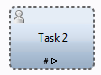
And finally … there is one more consideration to be discussed. There is the notion of a
"precondition". A precondition is a true/false valued expression where the expression must evaluate
to true before the activity can be performed. Within Process Designer, there is the following
control:
最后...还有一个原因要考虑到。有一个前提的概念。一个前提条件True/false的表达式，这个表达式的评估必须为true才能执行。

在设计中心，有一个控制如下:
By default it is unchecked which means that there is no precondition and the activity will run as per
the preceding rules. However, when it is checked, a new set of options become available to us:
默认值是未选中的这意味着那个是没有前提条件的并且这个活动将按照上面所述的规则运行，然而，检查的时候一个新的选项显示给我们:

Here we can add expressions which will be evaluated. The expressions can be added by clicking
the "+" icon on the right side. When clicked, a new row is shown into which the expression can be
entered:
在这里我们可以添加一个表达式来控制，这个表达式可以点击右边的+号图标进行添加。点击的时候会产生一个新的可以输入的表达式:

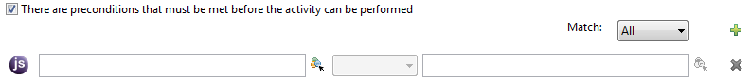
The expression can be made up of variables and constants with an operator between them.
这个表达式可以使用变量和常量和它们之间的运算符。

By clicking on the "JS" icon to the left (JavaScript) then an expression in JavaScript can be supplied.
通过点击左侧‘JS’图标（JavaScript），那么一个表达式可以在javaScript中提供。

When an expression is added to an activity, the existence of that expression is indicated in the
diagram by a small diamond:
当是一个表达式添加到一个活动的时候，这个存在的表达式将会以一个小钻石的样子标识在图形上:

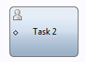
We should assume that the expression is reevaluated when ever a change is made to variables in the
Process.
我们假设表达式会重新评估在一个流程中的变量被修改的时候。

Now let us merge in this new notion with what learned previously.
现在让我们综合一下这个新概念的学习。

If an activity is automatically started but has a precondition, then it simply doesn't get to execute
until its expression becomes true. When the expression does become true, it immediately runs.
如果一个活动将自动开始但是有一个前提条件，那么它将不会执行一直持续到表达式为true。

If the activity is flagged as manually started and required but has a precondition, then if the
precondition expression is false, it shows as follows in Process Portal.
如果这个活动被标记为手动启动并且是必需的但是有一个前提条件，然后如果这个前提条件的表达式为false，它在流程Portal里面的时候会显示成这样:



There is nothing that can be done with it at this point other than Process Portal showing us that it
exists. Until its corresponding precondition expression becomes true, it is ineligible to be manually
Started.
没有什么能够在流程Portal中显示成这样的时候去完成它，这种种情况持续到它的前提条件的表达式为true的时候他将可以被手动启动。

When the condition becomes true, it becomes eligible to be started and the icon changes to:
当它的前提条件是true的时候，它就有资格开启并且图片会被改变成这样:

Page 178 End -
Page 179 Start -
If the condition becomes false again, then the activity will remain in its ready to be manually started
State.
如果这条件再一次变成false，那么这个活动会保留它准备好的手动启动状态。

If the activity is flagged as manually started and optional but has a precondition and that expression
is false, is shows in Process Portal as follows:
如果这个活动呗标记为手动启动并且是可选但是它有一个前置条件并且那个条件是false，他在流程Portal中将会显示成这样:

Again, there is nothing further that we can do with this activity at this point until its corresponding
expression becomes true. When it does become true, it becomes eligible to be manually started:
又一次，没有什么能够使我们能够进一步做这个活动在这个活动的前置条件变成true之前，当条件变成true的时候，就可以手动启动


Should the expression subsequently become false before it is started, it remains in its ready to be
started state.
这个活动应该在他的前置条件变成false之前启动完成，它仍然在准备状态。

The Process Portal icons for activities can be summarized as:
这些在流程Portal里活动图标的出现我们可以总结成这样:

Icon | Description
 | 任务可以开始并且它是必需的
 | 任务可以开始但是它是可选的
 | 任务还没开始并且它是必需的
 | 任务还没开始但是它是可选的.

参见:
• 案例 管理
• 处理其他临时安全的活动
Start Event
开始事件
The Start Event is a starting node that can be used to indicate the starting point of an instance of a
process. When added to the canvas, it looks as follows:
这个开始事件模型是一个始节点，它能够表示过程的起点，当它添加到画布上的时候，它看起来如下:

By default, when a new BPD diagram is created, a Start Event node is automatically added to the
Diagram.
默认情况下，在一个新的BPD图表创建完成的时候，一个始节点会自动添加到图表上。

The Start Event node is used to model the start of a process. From an implementation
perspective, the Start Event node is used when one wishes to:
这始节点是用于一个模型流程的开始。从实现角度来看，这个始节点什么时候用：

• Start an instance of a process through the Process Portal
• 开始一个流程的实例通过流程Portal
• Define a BPD as a linked process. Every called linked process must have a Start Event.
• 定义一个BPD作为链接流程，每一个链接过程必须得有一个始节点。

In either of these circumstances, execution of the process will begin from this node. A BPD can
only ever have one Start Event contained within it. Although the PD allows us to mechanically add
more than one start event, the run-time detects this and flags it as an error.
在这两种情况下，执行的流程将从这个节点开始。一个BPD只能且必须包含一个起始节点。

A Start Event can only have outgoing Sequence Lines from it. It is not permissible to have any
incoming links to it.
在BPD里面一个始节点只能有一个输出流程线。它不允许有任何流程线链接它。

Page 179 End -
Page 180 Start -

It is permissible for a process to have no Start Events but instead it must have one or more Start
Message Events. These allow the process to be started from an external event such as a UCA.
他不能允许一个流程没有启动事件并且它必须有一个或多个的启动消息事件，这些允许使用一个外部事件如UCA来启动流程。
If a process has no Start Events and is attempted to be started, an exception is thrown which shows
a message similar to:
如果一个流程没有开启时间并且试图去启动它，那么会抛出一个异常消息类似于下面：
[9/2/11 11:16:52:717 CDT] 00000089 wle E CWLLG2229E: An exception occurred in an
EJB call. Error: Cannot start BPD "BPD3". No start event of type None is found

Author: This message frustrates me … "No start event of type None is found". Personally, I
would have preferred to see "A start event of type 'None' was not found within the BPD named
'BPD3'".
作者的话：这个消息使我非常无语..."没有找到启动事件的类型".就我个人而言，我宁愿看到“一个启动时间的类型‘NONE’在这个BPD3中没有找到”。

End Event
结束事件
The End Event is used to model the end of a process. When added to the canvas, it looks as
follows:
这个结束事件模型用于结束一个流程，在添加到画布上的时候我们可以看到如下:

An End Event is added to the default BPD diagram when it is created.
一个结束事件添加到默认的BPD图表在它创建完成之后。

There can be multiple End Event nodes in a diagram.
在一个图表中可以有多个结束事件。

The process instance will come to an end only when all the concurrently
executing branches reach their End Events. Explicitly, the process will not end when any one single
branch reaches an End Event.
所有并发流程都走到结束事件的时候，这个流程实例将会结束，显然，它不会因为任何一个分支到达结束事件而结束。

Message Start Event
消息启动事件
The Message Start Event is a starting node that can be used to initiate an instance of a process due
to the arrival of an event. Once added to the BPD canvas, it looks as follows:
这个消息启动事件是一个启动节点，可以用来当一个事件的到来的时候启动一个流程的实例，一旦添加到BPD的画布，它看起来如下:

An instance of the process can be started based on this element when an external event occurs.
一个流程的实例可以基于外部因素开启的时候使用这个元素。

The association between the process and the mysterious external event happens as a result of an
undercover agent (UCA).
他们之间的关联过程和神秘的外部事件发生时是由秘密代理UCA）决定。

When the Message Start Event element is added, the properties of that
element allow us to define which UCA should be used:
在这个消息启动时间元素添加完成的时候，该元素的属性运行我们定义UCA来触发它:

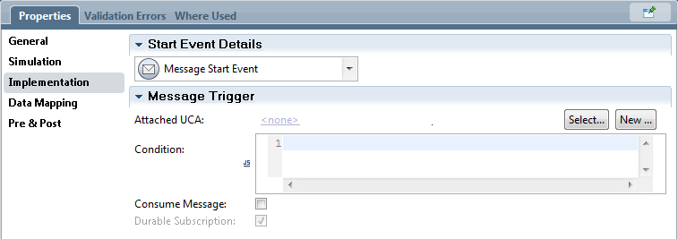
When the UCA fires the data from the UCA is passed as the starting data to the new instance of the
当UCA点火的时候UCA的数据作为起始数据传递给新实例的
Page 180 End -

